Johnson Trotter algorithm to generate permutations.=
#include <stdio.h>
#include <stdlib.h>

#define LEFT_TO_RIGHT 1
#define RIGHT_TO_LEFT 0

int searchArr(int a[], int n, int mobile) {
for (int i = 0; i < n; i++)
if (a[i] == mobile)
return i + 1;
return -1;
}

int getMobile(int a[], int dir[], int n) {
int mobile_prev = 0, mobile = 0;
for (int i = 0; i < n; i++) {
if (dir[a[i] - 1] == RIGHT_TO_LEFT && i != 0) {
if (a[i] > a[i - 1] && a[i] > mobile_prev) {
mobile = a[i];
mobile_prev = mobile;
}
}
if (dir[a[i] - 1] == LEFT_TO_RIGHT && i != n - 1) {
if (a[i] > a[i + 1] && a[i] > mobile_prev) {
mobile = a[i];
mobile_prev = mobile;
}
}
}
return mobile;
}

void printOnePerm(int a[], int dir[], int n) {
int mobile = getMobile(a, dir, n);
int pos = searchArr(a, n, mobile);

if (dir[a[pos - 1] - 1] == RIGHT_TO_LEFT)
{int temp=a[pos-1]; a[pos-1]=a[pos-2]; a[pos-2]=temp;}
else if (dir[a[pos - 1] - 1] == LEFT_TO_RIGHT)
{int temp=a[pos]; a[pos]=a[pos-1]; a[pos-1]=temp;}

for (int i = 0; i < n; i++) {
if (a[i] > mobile) {
if (dir[a[i] - 1] == LEFT_TO_RIGHT)
dir[a[i] - 1] = RIGHT_TO_LEFT;
else if (dir[a[i] - 1] == RIGHT_TO_LEFT)
dir[a[i] - 1] = LEFT_TO_RIGHT;
}
}

for (int i = 0; i < n; i++)
printf("%d", a[i]);
printf(" ");
}

int fact(int n) {
int res = 1;
for (int i = 1; i <= n; i++)
res *= i;
return res;
}

void printPermutation(int n) {
int a[50], dir[50];

for (int i = 0; i < n; i++) {
a[i] = i + 1;
printf("%d", a[i]);
}
printf("\n");

for (int i = 0; i < n; i++)
dir[i] = RIGHT_TO_LEFT;

for (int i = 1; i < fact(n); i++)
printOnePerm(a, dir, n);
}

int main() {
int n;
printf("Enter number of elements: ");
scanf("%d", &n);

printf("Permutations are:\n");
printPermutation(n);

return 0;
}
Output=
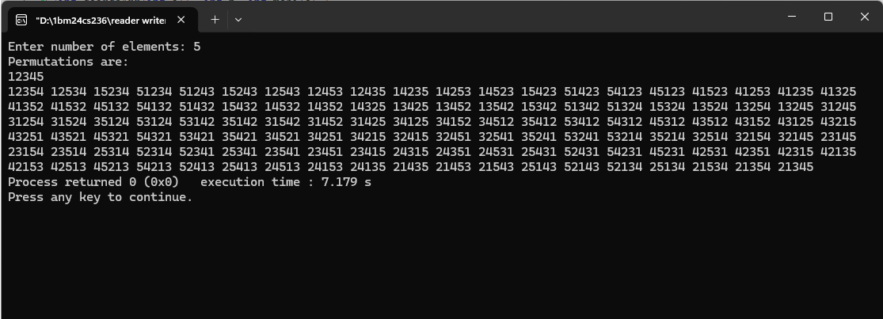

Coin Row problem=
#include <stdio.h>
#include <stdlib.h>

int max(int a, int b) {
return a > b ? a : b;
}

int main() {
int n;
printf("Enter number of coins: ");
scanf("%d", &n);

int *coins = (int *)malloc(n * sizeof(int));
printf("Enter coin values: ");
for (int i = 0; i < n; i++) scanf("%d", &coins[i]);

if (n == 0) {
printf("0\n");
return 0;
}

if (n == 1) {
printf("%d\n", coins[0]);
return 0;
}

int *dp = (int *)malloc(n * sizeof(int));
dp[0] = coins[0];
dp[1] = max(coins[0], coins[1]);

for (int i = 2; i < n; i++) {
dp[i] = max(dp[i - 1], dp[i - 2] + coins[i]);
}

printf("%d\n", dp[n - 1]);

free(coins);
free(dp);
return 0;
}
Output=
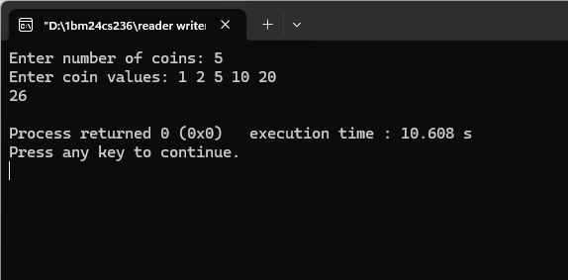
Change making problem=
#include <stdio.h>
#include <stdlib.h>

int min(int a, int b) {
return a < b ? a : b;
}

int main() {
int n;
printf("Enter number of coin types: ");
scanf("%d", &n);

int *coins = (int *)malloc(n * sizeof(int));
printf("Enter coin values: ");
for (int i = 0; i < n; i++) scanf("%d", &coins[i]);

int amount;
printf("Enter amount: ");
scanf("%d", &amount);

int *dp = (int *)malloc((amount + 1) * sizeof(int));

for (int i = 0; i <= amount; i++) dp[i] = amount + 1;

dp[0] = 0;

for (int i = 1; i <= amount; i++) {
for (int j = 0; j < n; j++) {
if (coins[j] <= i) {
dp[i] = min(dp[i], dp[i - coins[j]] + 1);
}
}
}

if (dp[amount] > amount) printf("-1\n");
else printf("%d\n", dp[amount]);

free(coins);
free(dp);
return 0;
}
Output=
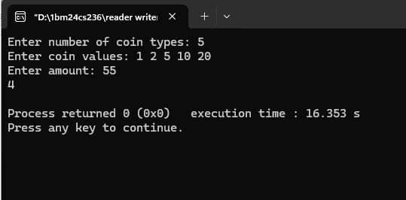
Coin collection problem=
#include <stdio.h>
#include <stdlib.h>

int max(int a, int b) {
return a > b ? a : b;
}

int main() {
int m, n;
printf("Enter rows and columns: ");
scanf("%d %d", &m, &n);

int **grid = (int **)malloc(m * sizeof(int *));
printf("Enter grid values:\n");
for (int i = 0; i < m; i++) {
grid[i] = (int *)malloc(n * sizeof(int));
for (int j = 0; j < n; j++) scanf("%d", &grid[i][j]);
}

int **dp = (int **)malloc(m * sizeof(int *));
for (int i = 0; i < m; i++) dp[i] = (int *)malloc(n * sizeof(int));

dp[0][0] = grid[0][0];

for (int i = 1; i < m; i++) dp[i][0] = dp[i - 1][0] + grid[i][0];
for (int j = 1; j < n; j++) dp[0][j] = dp[0][j - 1] + grid[0][j];

for (int i = 1; i < m; i++) {
for (int j = 1; j < n; j++) {
dp[i][j] = max(dp[i - 1][j], dp[i][j - 1]) + grid[i][j];
}
}

printf("%d\n", dp[m - 1][n - 1]);

for (int i = 0; i < m; i++) {
free(grid[i]);
free(dp[i]);
}
free(grid);
free(dp);

return 0;
}
Output=
